Annual Ward Report.
What a year it has been.
We would once again like to take this opportunity to thank each one of you, our communities and all those that have helped during what has really been an unprecedented and unusual year, it has been very hard on most people, but we have worked and pulled together throughout the year finding different ways of working, doing everyday activities and supporting each other. This work continues and we are hopefully on the right track to ease into a bit of normality. There are far too many people to thank personally but we hope that through our written and verbal updates throughout the year we have envisioned our thanks and appreciation. Kindness is always paramount.
We would like to repeat our thanks to the NHS, all the key workers (in which ever form you take, we are grateful), volunteers, people who have carried on working, worked from home, teaching including home schooling and being home schooled! Those that have supplied, delivered shopping, services & goods to our doors and to our local businesses for always going that extra mile to cheer people up and found new ways of working. The vaccinations are being carried out at an incredible rate but we must remember to not Wreck It Now… To Stick With it Suffolk…
Energy projects in our ward have been our focus and that of our Town and Parish Councils and will be on the agendas for some months/years. Our thanks go to everyone involved and to those that have taken the initiative and previously consulted within their communities as Town and Parish Councils so that local Cllrs can make sure that their views have been put forward, represented and understood. We thank those that are taking part, listening, writing and conveying people’s views during the SPR hearings. We would like to thank everyone again for their ongoing participation in these, especially as this will re replicated in the DCO hearing process for Sizewell C etc. Having Town and parish Councils working collaboratory consolidates the views that have been represented to the Councils and to us, which we have passed on at every available opportunity, verbally and in writing.
We would also like to take this opportunity to thank our retiring Suffolk County Councillor, Cllr Russ Rainger for his help, support and advice over his term in office.
Planning matters continue to keep us remarkably busy and once again we ask you to get in touch, copy us in on your comments and make sure you contribute your views at the planning committee meetings (covered once again in our March report)
Throughout the year we have informed you of matters within the ward, for once, this report is relatively short as Covid-19 has been a priority for many. If you would like news from further afield, please do keep updated via the website.
Our absolute best wishes,
T-J and Jocelyn. 9th March 2021.

Enabling Communities Grants
Due to the Covid-19 pandemic, each district councillor allocated £1,000 or £2,000 from their 2020/21 Enabling Communities Budget (ECB) budget towards a new Covid-19 hardship fund. A further £45k was subsequently added to the Covid-19 Hardship Funding from councillors ECB.
We donated £2000.00 each from our pot this year towards supporting Covid-19 leaving us with £5500.00 each.
Below is how TJ and Jocelyn supported groups and projects with the remainder of their budgets::
Aldeburgh Town Council Funding to carry out a housing survey.
Theberton & Eastbridge Parish Council Funding to provide broadband/wifi to the village Hall.
Snape Good Neighbour Scheme Funding to purchase a wheelchair for community use.
Theberton & Eastbridge Parish Council Funding to install a petanque piste 12m x 6m on Theberton playing field
Aldeburgh & Blyth Community Radio Funding to purchase radio equipment for the community station.
Snape Parish Council Funding for improvement of green and open spaces throughout the village to enhance the visual appearance and biodiversity of the village in line with the work Green Snape has done over the past 3 years which culminated in the village being recognised by SCC/ESC as Suffolk's ”greenest community 2019”.
Middleton Cum Fordley Parish Council To extend disabled car parking space at the village hall
Railway Farm Shop, Benhall. The project is seeking funds to set up a Community Hub at the Farm Shop.
Aldeburgh Business Association Funding towards Christmas decorations etc for local businesses/community
For more information on the ECB grant pot (£7,500 per Cllr) please go to:
https://www.eastsuffolk.gov.uk/community/community-grants-and-funding/enabling-communities-budgets/

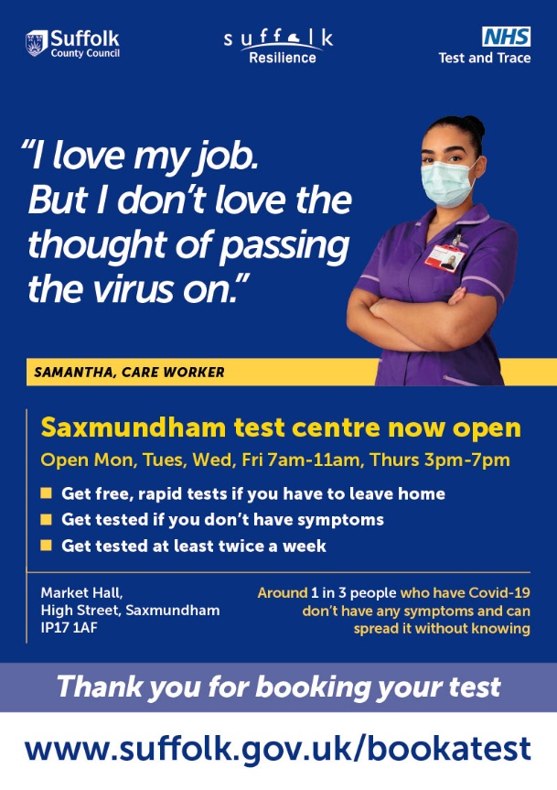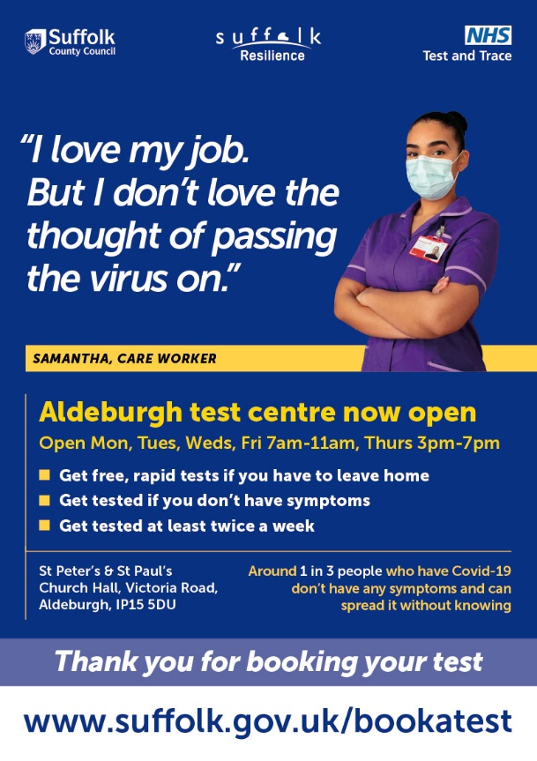

Council tax freeze to further support residents
In response to the challenges faced by local communities during the pandemic, East Suffolk Council has frozen its element of council tax for the coming year.
The pandemic has seen many residents with reduced income and many more with serious concerns about maintaining their financial security. Whilst only a small percentage of each household’s council tax bill goes to East Suffolk Council, it is our hope that freezing our element of this year’s bill will provide further support for those in need

Apply for a postal vote
There will be several elections this year, including the Police and Crime Commissioner, County Council and local by-elections for some areas.
If you are registered to vote, you can arrange a postal vote for these elections now:.
https://www.electoralcommission.org.uk/i-am-a/voter/voting-person-post-or-proxy/voting-post
If you are not yet registered to vote, you can register to vote at www.gov.uk/registertovote

All welcome at annual meeting
Residents with physical, sensory or learning difficulties or mental health concerns, along with their parents and carers, are invited to attend the Waveney Disability Forum’s AGM next week.
The virtual meeting takes place on Tuesday 16 March via Zoom and is open to anyone with a disability living in the local area.
The meeting will focus on mental health services and support for people with disabilities of all ages. This is particularly important as coronavirus restrictions begin to ease which may cause stress or anxiety for some people, especially those who are clinically vulnerable. The meeting is an opportunity to share details of the support available for individuals, families and disability organisations, as well as how to access this support and share good practice.
The Waveney Disability Forum creates an opportunity for people with disabilities and disability organisations in the local area to come together to consult directly with East Suffolk Council on the services and facilities which affect them.
The meeting, which begins at 10am, is open to members of the public but also service providers who may wish to share details of the mental health support they are offering people with disabilities.
Anyone wishing to attend is asked to contact Stuart Halsey via stuart.halsey@eastsuffolk.gov.uk or 07768 114421.

Wildlife to benefit from more wild spaces
More conservation areas are being created to benefit wildlife as part of East Suffolk Council’s commitment to increase biodiversity areas.
Last year, 40 wild spaces were created across East Suffolk as part of the Council’s ‘Pardon the weeds, we’re feeding the bees’ campaign, where grass was left to grow longer and wildflowers planted to help wildlife thrive. These spaces were cut back for winter and the signs removed but will be returning over the next couple of weeks.
This year, a further 60 wild spaces have been identified, meaning there will now be 100 wild spaces across East Suffolk where grass and wildflowers will be left to grow and the areas will not be cut until the end of the season.
These areas, which are large enough to provide an environmental benefit and do not present any safety issues for local communities, will be marked with our ‘Pardon the weeds, we’re feeding the bees’ signs to make residents and visitors aware.

Have you got your census letter?
Households across East Suffolk are being asked to take part in Census 2021.
Census day is on Sunday 21 March, but households will now be receiving letters with online codes explaining how they can complete their forms. If you don’t get one in the next couple of weeks, please get in touch with the census contact centre. You can also request a paper questionnaire if you’d prefer to complete your census that way.
Local census support centres will be open while the census is happening. Staff will offer help for people not confident online, who don’t have a computer or need help completing on paper.
There are two dedicated Census Support Centres in East Suffolk – one at the Marina Centre in Lowestoft which will be operated by staff from East Suffolk Council's Customer Services team, and one at the Station House in Campsea Ashe, operated by the social enterprise there. These centres will not be open to the public to visit but can offer help with completing your census form over the telephone and can answer general enquiries.
- Marina Centre Census Support Centre: 01502 523523
- Station House, Campsea Ashe Census Support Centres: 07856 810828
The census is a once-in-a-decade survey that gives us the most accurate estimate of all the people and households in England and Wales. It has been carried out every decade since 1801, with the exception of 1941.
For more information, go to census.gov.uk or call 0800 141 2021.

Suffolk partners with environmental charity in new campaign to stop people trying to recycle disposable nappies
National survey reveals that more than one million UK nappy users are putting them in their recycling bin.
The Suffolk Waste Partnership has joined forces with environmental charity Keep Britain Tidy and other local authorities across the country to launch a new campaign aimed at stopping the millions of disposable nappies that are contaminating recycling. The campaign comes after a new survey revealed that seven per cent of nappy users – parents, grandparents and carers – wrongly put their disposable nappies in with their recycling, which equates to more than *one million people.
Locally, around 150 tonnes of nappies end up in Suffolk recycling bins each year. This equates to approximately 3000 nappies needing to be removed from the recycling every day. This truly unpleasant job needs to be done by hand by staff at Suffolk’s Material Recycling Facility (MRF) in Gt Blakenham. So, by keeping nappies out of our recycling bins, you are not only helping to get our recycling right but protecting staff at the MRF.
The national survey, carried out by YouGov, also revealed that younger people, aged 18-24 were more likely to put them in their recycling bin (15%) and more than one in ten Londoners who used disposable nappies (11%) tried to recycle them.
Now, the Suffolk Waste Partnership is trying to reach nappy users with a new campaign that has been tested with them and offers a clear message that disposable nappies should never go in their recycling. The campaign is fronted by ‘Ted’ and will be appearing on billboards around the country and on social media to drive the message home. In Suffolk, additional information will be shared on the Suffolk Waste Partnership’s website, social media channels and newsletters.
Putting the wrong things in your recycling bin can spoil the entire contents and removing used nappies is a particularly nasty job. We are therefore asking residents across Suffolk to ensure nappies never go into your recycling bin. Please always put them in the rubbish bin or consider switching to cloth nappies. These small but important changes can really help our local environment.
Keep Britain Tidy’s Chief Executive Allison Ogden-Newton OBE said:
“We are delighted to be partnering with the Suffolk to tackle this issue. Recycling contamination, including disposable nappies, costs local authorities hundreds of thousands of pounds a year and stops many tonnes of waste from being recycled. “The message to everyone who uses disposable nappies is clear – nappies never go in your recycling.”
Keep Britain Tidy is also calling on nappy manufacturers to label their products as non-recyclable to help avoid confusion.
Allison added: “We know from our research that there is confusion among the public about recycling – our survey has found that a third of nappy users admit to being confused - so we call on all manufacturers of disposable nappies to use eye-catching labelling that clearly communicates their product cannot be recycled. Our campaign features a new symbol that we would like to see carried on every pack of nappies so that there is clear and consistent advice to the public, many of whom are trying to do the right thing with what they perceive, incorrectly and tragically, is a recyclable product."

Progress shown on delivering Local Plans
Data showing the progress on the implementation of the Suffolk Coastal and Waveney Local Plans has now been published.
Every year, East Suffolk Council produces a report to show the progress on producing Local Plans and the delivery of policies and proposals. The Authority Monitoring Report 2019/20 is now available and contains a range of monitoring data covering housing, economy, retail and town centres, the historic and natural environments and many more topics. More info on the website.

Helping East Suffolk businesses thrive online
Small businesses in East Suffolk are invited to sign up to free support to help their businesses thrive online using digital skills.
The Digital Advice Service, launched by East Suffolk Council in November 2020, offers free support to small businesses in East Suffolk – especially those in the retail, leisure and hospitality sectors, who may need help with creating or improving their website, online shop or social media presence. The service offers extensive digital business support, a personalised session with a dedicated business growth coach, access to workshops from local experts and industry experts and group coaching sessions, as well as signposting to other forms of support.
Once enrolled, businesses are also eligible to apply for an East Suffolk Digital Grant of up to £1,000 to help them implement new digital changes, such as improving a website, installing new online systems or attending further training.

Celebrating East Suffolk’s best building design
The winners of an annual awards programme which celebrates the best building design and conservation projects in East Suffolk have been announced.
East Suffolk Council’s ‘Quality of Place Awards’ recognise the efforts of people across the district to enhance the quality of the environment, by creating high-quality designs in both the built and natural environment and helping to conserve historic buildings.
Building Conservation Award, Highly Commended - Aldeburgh Moot Hall Regeneration Project.

An extra £3m for warmer, greener Suffolk homes
More Suffolk residents are set to benefit from Government Green Homes Grants thanks to a further successful bid for £3m funding by a Suffolk consortium of local authorities, adding to a previous award of £1m secured last year.
The funding, provided by the Department of Business Energy and Industrial Strategy, will provide energy efficiency measures for owner occupiers of properties with poor energy performance ratings. Partner local authorities are already working on delivering five projects and have a completion deadline of September for the five new schemes. These are external wall insulation of 100 park homes in West Suffolk, 150 park homes in East Suffolk, and 70 Flagship Group properties, insulation and air source heat pumps on 100 homes in Babergh and Mid Suffolk, and internal wall insulation for 10 properties through Leiston Net Zero/EDF.

Further funding secured to help rough sleepers
East Suffolk Council has secured nearly half a million to help support rough sleepers in the district. In September 2020, East Suffolk Council received £93,312 as part of the Government’s Next Steps Accommodation Programme (NSAP) to provide accommodation and support to rough sleepers during the pandemic.
Following a successful bid, the Council has secured an additional £389,482 from the Ministry of Housing, Communities and Local Government in the next stage of the NSAP to provide additional support to rough sleepers in East Suffolk and to deliver units of longer-term move-on accommodation.

East Suffolk households asked to follow bin rules
Households in East Suffolk are being reminded to follow bin guidelines as more household waste is created during national Covid-19 restrictions. To help ensure an efficient refuse service, East Suffolk Council is asking that households follow a few simple guidelines as set out below:
• Put bins out by 6am latest on collection day
• Recycle where possible through the blue bin
• Present bin at the boundary of your property where your access meets the public highway or other agreed collection point
• Don’t force too much waste into a bin as it can stick inside, meaning it won’t come out when emptied
• Ensure bins do not contain any incorrect items, as it may not be emptied
• Ensure the lid on bins are closed for collections, otherwise we won’t be able to empty it
• Take bins in as soon as possible after collection as they can cause a serious obstructions and block access, particularly when left on public pavements and access ways
See more information on what items goes into what bin, to check your bin collection day and to report a missed bin collection. https://www.eastsuffolk.gov.uk/waste/waste-collection-and-disposal/refuse-collection/

Council aims to help vulnerable people stay active EAST Bags
Hundreds of vulnerable people in East Suffolk are set to benefit from EAST bags which will help them stay active during winter months. East Suffolk Council has been putting together 2,000 EAST bags, which will be delivered over the coming weeks to vulnerable older residents who have been identified as being at risk of loneliness and/or social isolation.
The EAST bag (Everyone Active, Supported Together) is a reusable jute bag which has been funded by the East Suffolk Community Partnership Board and Ipswich and East Suffolk Clinical Commissioning Group. Thank you to everyone that donated, packed and delivered the bags.

Council continues to fight impact of climate change
East Suffolk Council continues to tackle the impact of climate change as it works towards becoming carbon neutral. Since its creation in April 2019, East Suffolk Council has had an ambitious environmental vision to build the right environment for East Suffolk and it's committed to be carbon neutral by 2030.
To support this vision, the Council voted unanimously to declare a climate emergency in June 2019 in a bid to reduce its own carbon emissions and to encourage local communities to get involved in fighting climate change. Since then, the Council has taken a number of actions to help it achieve its ambitions plans and deliver its environmental vision to residents and stakeholders. As a direct result of the declaration, a cross-party Environment Task Group was established to ensure the Council’s policies meet its environmental vision and identify areas for improvement through the development of a Climate Action Plan.

Council passes on Government grants to Towns and Parishes
East Suffolk Council has agreed to a new scheme which supports Towns and Parishes when setting budgets next year. Nationally, the Government is providing £670m in grants to support councils in respect of the impact of the Covid-19 pandemic on council tax income. East Suffolk Council will receive £370,000 of this grant, which includes an element relating to the effect on town and parish councils, estimated to be around £110,000.
East Suffolk Council agreed to a scheme that directly passes on the £110,000 to town and parish councils with allocations based on reductions in income from council tax to ensure that support is directed at the Towns and Parishes mostly affected.

Have your say on Council’s budget priorities – We asked for your views.
Residents and businesses were invited to have their say on East Suffolk Council’s spending priorities before budget was set.
East Suffolk Council launched a consultation to enable local people and businesses to have their say on what they would like the Council’s 2021/22 budget to focus on to ensure it continues to deliver vital services and support to communities and businesses.

East Suffolk does its bit for National Tree Week – keep planting
East Suffolk councillors ‘dug in’ to help support National Tree Week, the UK’s largest annual tree celebration.
As part of East Suffolk Council’s commitment to the environment, councillors supported National Tree Week, which marks the start of the winter tree planting season, by digging in and planting new trees.

Have your say on new planning document, we asked for your views.
East Suffolk residents were invited to have their say on new planning document which seeks to protect and enhance the district’s historic environment. East Suffolk Council sought the public’s view on a new Historic Environment Supplementary Planning Document (SPD) with an eight-week consultation.
East Suffolk has an historic environment which is widely recognised as being of very high quality and importance, with approximate 4,000 listed buildings and 52 conservation areas. Its local character and distinctiveness are derived from the diversity of architecture, landscape and coastal settings, which have given rise to an architectural typology of farmhouses, picturesque cottages and churches as well as resort tourism, military research and defense, fishing and agri-industry, park and garden structures, energy and landed estates.

Free was parking made available
To coincide with the easing of national coronavirus restrictions which will enable a wide range of businesses to reopen, free 30-minute parking was made available in 48 of East Suffolk Council’s car parks.. East Suffolk Council agreed to extend its existing free parking scheme to an additional 13 car parks in response to concerns from local businesses about the impact of Covid-19. These changes were introduced on Friday 4 December, meaning that the Council’s 30-minute free parking tariff will be available in 48 different car parks across the district.
Thank you once again for those that did take part, advertised and contributed towards the Car Park consultation.

Simplified parking tariffs to be rolled out
Following a delay caused by the Covid-19 pandemic, East Suffolk Council rolled out new parking tariffs across the district - including a simplified pricing structure and free half hour parking across a number of sites. Reducing over 50 different price points to just three or four main ticket types across the district, the new price structure will see prices reduced or frozen in over 70% of cases. Additionally, the council has introduced 30 minutes free parking in a number of car parks to support people who have told us that they make regular short visits. This will also support local businesses who will benefit from drivers making quick turnarounds in our car parks.
Ringo Available in all East Suffolk’s car parks, RingGo is a quick and easy to use mobile phone service which lets people pay for their parking with a credit or debit card, via an app, rather than using cash at the machine. This means that drivers no longer need to queue at the machine or handle cash to pay for their parking. Whilst there used to be a convenience fee of 20p to use the app, East Suffolk Council covers this cost, so drivers do not get charged extra for using this payment option. There is however a small extra charge if drivers choose to opt in to receive SMS reminders, of when you time is running out.
To register with RingGo and go contactless, go to https://ringgo.co.uk/.
Parking management moved from the police to East Suffolk Council in April 2020, to improve parking locally and tackle nuisance and unlawful parking, enabling the Council to address the parking problems that are affecting communities the most.

We urged Residents to shop local for Christmas
As national coronavirus restrictions are lifted, we urged shoppers across East Suffolk to shop locally and support their local high street in the run up to Christmas.

People urged to stay away from cliffs – please keep safe at all times
Residents and visitors are being urged to take care when visiting the East Suffolk coast after a child was seen playing at the base of cliffs. Earlier this year, a campaign was launched by Coastal Partnership East in conjunction with HM Coastguard to remind people to stay safe on the coast, especially when walking near cliffs.

Free webinars for adult learners
Supported by Suffolk County Council, East Suffolk Council and Community Action Suffolk, the East Suffolk Community and Adult Learning Network offered two free webinar sessions. The sessions, delivered via Zoom, were open to any learning provider or community group who offer formal or informal learning.

Green tips to reduce your energy usage and bills!
New nationwide restrictions mean that more of us are working and worked from home and thereby using more energy – from running lights and laptops to boiling the kettle more often. With more people working from home due to ongoing Covid-19 restrictions, East Suffolk Council encourages residents to find out more about how they can reduce their energy use to save money on their bills and help protect the environment.
There are many simple steps you can take now to start reducing your energy usage, including:
- Turn off the heating in rooms you don’t use and avoid having it on all day. Try turning the thermostat down degree by degree to find a comfortable temperature
- Unplug all chargers and turn off tablets, laptops and consoles when not in use
- Avoid turning on lights during the day unless you need them and make sure everyone turns off every light when leaving a room
- When making hot drinks, only boil the amount of water you need for the number of drinks you’re making at the time
- Wash laundry at 30 degrees unless it’s really dirty
- And remember, you need to ‘switch off’ too and plan regular breaks during the day when working from home - why not enjoy a walk in your local park or in the countryside?

New eBook celebrates East Suffolk’s volunteers
Hundreds of volunteers stepped up and dedicated their time to help in their local communities in East Suffolk during the pandemic – it is our turn to say thank you! East Suffolk Council created a new eBook to celebrate the people, organisations and businesses who have given up their time, knowledge and skills to help make a difference in their communities since the start of the Covid-19 outbreak. The eBook tells the stories of some of our volunteers and showcases the important work they have carried out – and continue to carry out – to support the most vulnerable in their communities.

Shared ownership scheme is district first
As part of a comprehensive development programme to deliver vital new housing, East Suffolk Council was delighted to introduce six new shared-ownership properties to its housing stock – the first of their kind in the district. The properties are located in Brampton with Stoven near Halesworth and provide an affordable ownership scheme, which combines purchasing a share in a home with a rental agreement for the remaining unowned share.

Residents encouraged to tackle air pollution at home
East Suffolk residents are being encouraged to take simple steps to protect their health, and the health of their families, from air pollution at home.
Clean Air Day is the UK's largest air pollution campaign and aims to tackle and raise awareness of air pollution. Due to coronavirus restrictions, Clean Air Day was held online and was and is a chance to find out more about air pollution, share information with friends and colleagues, and help make the air cleaner and healthier for everyone. Resources, including air pollution videos, checklists and a personal air pollution calculator, are available at www.cleanair.org.uk

New service for council tenants.
East Suffolk Council’s housing tenants are able to manage their tenancy more easily using a new online service.
A new portal, called ‘myHome East Suffolk’ was launched and enables those living in council properties to manage payments, request repairs and make appointments quickly and easily. The portal is accessible at any time of day, every day of the year meaning that tenants can access the portal at a time most convenient for them, removing the need to contact the Council’s Housing or Customer Services teams during office hours.

New ‘Local Plan’ approved
East Suffolk Council have adopted the Suffolk Coastal Local Plan - an ambitious strategy to guide and manage new development for the former Suffolk Coastal area in a sustainable and plan-led way.
It proposes to deliver at least 6,500 jobs and 9,756 new homes over the period to 2036, supported by the delivery of appropriate infrastructure whilst also setting out an approach to protect, maintain and enhance the high quality built, historic and natural environment; and mitigate and adapt to climate change.

East Suffolk Council elected a new Chairman
East Suffolk Council elected a new Chairman at virtual Annual Meeting, which was held on 23 September. Cllr Keith Robinson, who represents the Oulton Broad ward, will be Chairman for the remainder of the 2020/21 Municipal Year, taking on the post from Cllr Colin Hedgley.

Council charges forward with new electric vehicles
East Suffolk Council has introduced new electric vehicles to its fleet as part of its commitment to tackle climate change. East Suffolk Council is continuing to proactively take steps to reduce its carbon emissions by introducing six new electric vehicles to its fleet run by partners, East Suffolk Norse. The environment is a key principle of East Suffolk’s Strategic Plan and, alongside its declaration of a climate emergency last year, the council is committed to environmental issues and fighting climate change.

New bins to help keep Aldeburgh tidy, now in other locations. Please help to promote these.
To encourage people to dispose of their rubbish correctly and reduce littering, a new style of litter bin was trialled in Aldeburgh. Having listened to residents’ views, East Suffolk Council has worked with Aldeburgh Town Council to review the litter bins provided in the town. The audit considered the style and size of bin, as well as their location.
Much of the rubbish being discarded is from takeaway and fast-food businesses, which is not only unsightly and damaging for the environment but is also attractive to pests. To deter pests and gulls from removing waste from bins, and to prevent rubbish being blown out, any open top or ‘flip top’ style bins have been removed where possible. These have been replaced with larger bins which are uniform in colour and size and are clearly located along the seafront.

East Suffolk towns to be digitally transformed (previously an SCDC initiative)
Twelve towns in East Suffolk will benefit from new technology including free WiFi and footfall tracking, to help high streets and town centres recover from the impact of Covid-19. Following a successful pilot in Framlingham last year, East Suffolk’s ‘Smart Towns’ Project will now be rolled out to 11 other market towns across the district. The project will provide free WiFi for visitors in the main shopping areas of each town, as well as providing footfall tracking technology to help town councils and business groups understand how and when residents and visitors use these areas. This data will enable them to improve services and offerings to attract more visitors, as well as gauging the success of events and specific promotions.
‘Smart Towns’ uses the same principles as ‘Smart City’ technology, where urban areas use electronic data to continuously monitor and improve services. However, ‘Smart Towns’ will instead use this technology to benefit rural town centres, high streets and communities.
Many local businesses have been adversely affected by Covid-19 and it is hoped the project will help ensure business sustainability. As well as free WiFi and footfall tracking, the ‘Smart Towns’ project will provide a ‘digital springboard’ for local businesses, enabling them to maximise the benefits of the digital economy. Businesses will be able to access digital diagnostics, workshops and coaching to help them get the most from new technology, such as improved websites and social media use, contactless payments, online booking systems, or attracting customers through digital vouchers, apps and loyalty schemes.
In addition to Framlingham, the scheme will now be introduced in Aldeburgh, Beccles, Bungay, Felixstowe, Halesworth, Leiston, Lowestoft, Saxmmundham, Southwold, Wickham Market and Woodbridge.

Council trials new scheme to reconnect older residents Grandpads
East Suffolk Council started trialling a new scheme which helps reconnect older residents who are vulnerable due to social isolation.
The East Suffolk Grandpad Loan Scheme is aimed at tackling social isolation amongst mainly older residents who have little or no contact with loved ones or the outside world due to a lack of Wi-Fi, equipment and/or skills. Grandpads have been specifically designed around the need of older adults, and the large buttons and intuitive interface make it easy for older people to use the device to connect with loved ones and the outside world without the complicated features of other tablets.

We asked for your views - New scheme launched to support fishing industry during pandemic
An initiative providing practical support to the fishing industry across the country was launched a scheme specifically to help those in the East of England.
Call4Fish is a nationwide initiative designed to facilitate and enable practical support to the fishing industry during the Covid19 crisis and beyond. It helps reconnect customers with suppliers, helps rebuild the supply chain and protects jobs. It also ensures customers can safely purchase high-quality sustainable fish and shellfish caught by British boats in home waters. Local authorities in Norfolk and Suffolk and the New Anglia Local Enterprise Partnership are working in partnership with Call4Fish and have launched Call4Fish (East) to support the local fishing industry from Kings Lynn to Felixstowe.
Call4Fish (East) will provide a range of services and work alongside local organisations who understand the issues and have a direct stake in supporting their communities. This local knowledge and expertise will help to deliver a much more joined-up and coordinated approach that can help protect jobs and ensure fishermen can go to sea.

A new campaign was launched to support those with financial worries
East Suffolk Council and its three local Citizens Advice services launched a new campaign to remind residents with financial worries that free support and advice is available. To encourage people to talk about any money worries they have to avoid financial problems building up over time, East Suffolk Council and East Suffolk’s Citizens Advice services (CAs) have joined forces and launched a new campaign, titled ‘Money Matters – Managing Debt Together.”
The aim of the campaign is to direct people to the CAs, which provides free, independent, impartial, and confidential quality assured advice to those with money worries. The team can talk about any financial issues people may have – whether this is advice on debts, or if you’re worried about going into debt in the current climate – and explain the options and solutions available to address the issue.

Conservation areas identified across East SuffolkAs part of plans to increase biodiversity in East Suffolk, forty new conservation areas were created to benefit wildlife.
Non-essential grounds maintenance, including grass cutting, was temporarily suspended in April to ensure the safety of staff and the public. During that time, only grassed areas which presented a safety, visibility or access issue were cut. Some of the areas where grass was left to grow longer over the past two months have started to ‘re-wild’, with anecdotal examples of increases in insect and pollinator levels, and an increase in the numbers of wildflowers.*updated and added March 2021

Helping young people take positive next steps
A new online service was launched in East Suffolk, helping young people to find employment. The East Suffolk Youth Employment Service (YES) has been designed to help people from any background who may be struggling to find or apply for jobs, courses and training. The service is aimed specifically at 16 to 24 year olds. Funded by East Suffolk Council, Suffolk County Council, Suffolk Public Sector Leaders and the former East Suffolk Partnership, YES is delivered by Inspire Suffolk with the support of Access Community Trust.
The YES programme was originally designed to be provided through hubs in Lowestoft, Leiston, Saxmundham and Felixstowe however the Covid-19 restrictions have meant the service is now being provided online. To support this, a new website (www.yessuffolk.co.uk) has been launched. Young people can visit the website to view current job opportunities, find training programmes, and other support information and advice. Referrals can also be made by community groups. Young people will be allocated an employment coach to support them into appropriate work, education or training. Wellbeing services are also available, provided by Inspire Suffolk.

Over 5000 businesses in East Suffolk received vital funding
East Suffolk Council makes its 5000th business grant payment in May 2020 and it continues to step up its support during the pandemic. East Suffolk Council received applications from businesses eligible for the Government’s business grants scheme. As part of this, the Council has contacted over 7000 businesses who they believe may be eligible for the Small Business Grant Fund of the Retail, Hospitality and Leisure Fund and anyone who thinks they may qualify under the Government’s criteria.

This report is in conjunction with our March 2021 ward report. Please see the reminders and information contained.
Please do share this report with others, your websites, notice boards and newsletters. However, please consider the monitory period coming in a couple of weeks’ time.

